AI-Based Speech Signal Analysis for the Detection and Monitoring of Amyotrophic Lateral Sclerosis Disease

(Graduation Project 1) prepared to obtain the degree of B.Sc. in the Department of Smart Communication Engineering and Data Science

Authors:
Laith Aldeen Abd Alrazek
Supervised by:
Dr.Rawad Melhem

Damascus:$\frac{هـ1448-1449}{م 2026-2027}$

1-1: Introduction
Artificial Intelligence (AI) and machine learning have revolutionized the healthcare sector by enabling automated, non-invasive diagnostic and monitoring tools. Neurodegenerative disorders, such as Amyotrophic Lateral Sclerosis (ALS), present severe medical challenges characterized by rapid motor neuron degeneration. Speech impairment (dysarthria) is one of the earliest and most prominent symptoms of bulbar-onset and generalized ALS. This project explores the intersection of artificial intelligence and biomedical signal processing, focusing on leveraging advanced audio analysis and deep learning models to detect and monitor ALS progression through voice signals.

1-2: Research Problem
Amyotrophic Lateral Sclerosis (ALS) is a severe neurodegenerative disease where patients progressively lose muscle control, prominently affecting speech through dysarthria. Currently, tracking disease progression and diagnosing ALS early remain challenging due to the heavy reliance on subjective, periodic clinical tests (such as the ALS Functional Rating Scale - ALSFRS). These traditional methods can be infrequent, prone to subjective bias, and fail to capture continuous, subtle day-to-day functional changes in patients' speech patterns. Therefore, there is a critical need for an objective, automated, and continuous AI-driven monitoring system based on speech analysis.

1-3: Research Objectives
- Main Objective:
To develop an intelligent AI-based system capable of accurately detecting Amyotrophic Lateral Sclerosis (ALS) and continuously monitoring its progression through speech signal analysis.
- Sub-Objectives:
  - Achieve high classification and detection accuracy (targeting 90%).
  - Extract robust acoustic features and utilize state-of-the-art deep learning architectures (such as Audio Spectrogram Transformers - AST).
  - Process audio spectrograms distinguishing normal voices from dysarthric voices caused by neurodegeneration.
  - Assist clinicians with objective quantitative indicators to support patient care and treatment planning.

1-4. Solution Idea
Inspired by the SAND challenge, the proposed solution focuses on leveraging advanced artificial intelligence and deep learning models to detect and monitor Amyotrophic Lateral Sclerosis (ALS) through speech signal analysis.
The system processes audio recordings (such as sustained vowel phonations and syllable repetitions) from patients to capture the acoustic characteristics of ALS-induced dysarthria. The core methodology involves extracting robust acoustic features—including Spectrograms, Mel-Frequency Cepstral Coefficients (MFCCs), and Phoneme PosteriorGrams (PPGs)—and passing them into state-of-the-art transformer-based architectures, specifically the Audio Spectrogram Transformer (AST), to perform accurate classification and track disease progression over time.

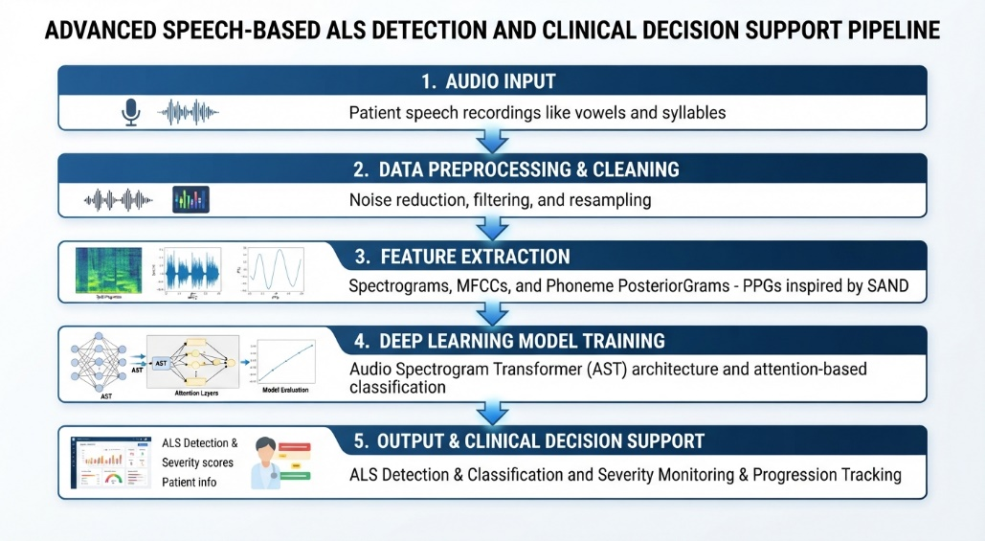

Chapter 1

Theoretical Background
This chapter presents the theoretical foundations required to understand the proposed system, including the medical background of ALS, clinical rating scales, principles of speech signal processing, and deep learning architectures used in this study.

  - Overview of Amyotrophic Lateral Sclerosis (ALS)
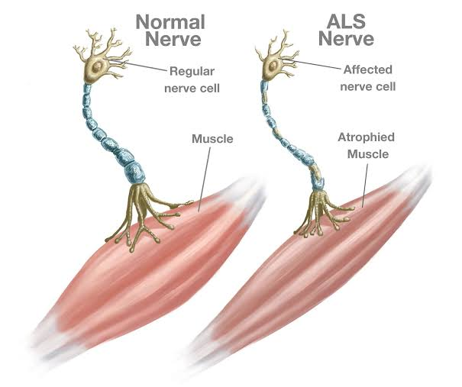
Amyotrophic Lateral Sclerosis (ALS) is a progressive neurodegenerative disease affecting motor neurons in the brain and spinal cord. As the disease advances, patients gradually lose control over voluntary muscles. A prominent and early symptom of bulbar-onset ALS is dysarthria (motor speech disorder), which significantly alters vocal tract dynamics, articulation, and voice quality. Understanding these physiological changes is fundamental for developing acoustic-based diagnostic tools.
Figure 1:Comparison between normal and ALS affected motor nerves.

1.2 Speech Signal Processing and Acoustic Features
Raw audio signals captured from patients cannot be directly fed into deep learning models. Therefore, a robust speech signal processing and feature extraction pipeline is essential to convert acoustic waveforms into meaningful numerical representations. This process generally involves two main stages:
1.2.1 Preprocessing and Cleaning:
Before extracting features, raw audio recordings undergo several preprocessing steps to ensure consistency and quality:
- Resampling: Converting all audio files to a standardized sampling rate to maintain uniformity across the dataset.
- Audio Trimming: Removing leading and trailing silent intervals from the audio recordings to ensure that the analysis focuses strictly on active speech segments.
- Framing and Windowing: Because speech signals are quasi-stationary over long durations, the continuous audio stream is segmented into short, overlapping frames (typically 20–30 ms) multiplied by a window function (such as Hamming window) to prevent spectral leakage.
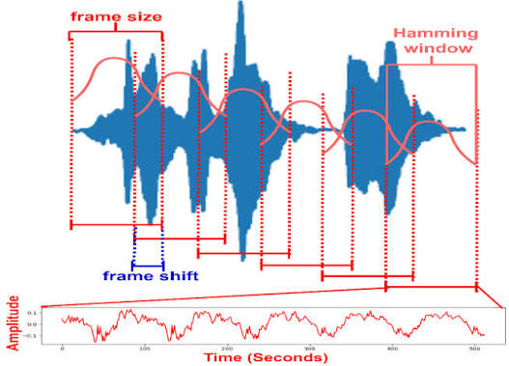
Figure 2: framing and windowing of speech signal

1.2.2 Acoustic Feature Extraction
To capture the pathological changes in speech caused by ALS-induced dysarthria, specific acoustic features are extracted from the preprocessed frames like spectrograms. it provide a visual representation of the spectrum of frequencies of a sound signal as they vary with time. By converting 1D time-domain audio signals into 2D time-frequency representations, spectrograms capture both temporal and spectral characteristics, making them optimal inputs for advanced transformer-based architectures like the Audio Spectrogram Transformer (AST).

1.3 The ALS Functional Rating Scale (ALSFRS)
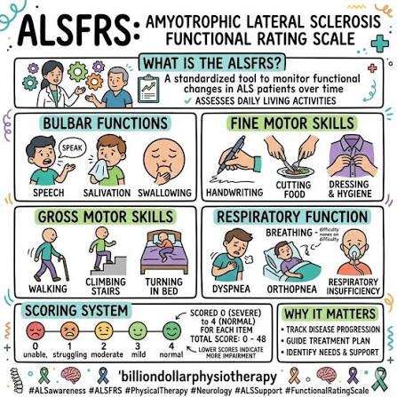
The ALS Functional Rating Scale (ALSFRS) is a validated standardized tool used to monitor functional changes in ALS patients over time. It assesses daily living activities, including bulbar functions (speech, salivation, and swallowing). Correlating automated speech analysis metrics with ALSFRS scores provides an objective, quantitative approach to tracking disease progression.
Figure 3: ALS functional rating scale (ALSFRS)
1.4 Deep Learning and the Audio Spectrogram Transformer (AST)
1.4.1 Overview and Background of AST
With the advent of deep neural networks, over the last decade audio classification research has moved from models based on hand-crafted features to end-to-end models that directly map audio spectrograms to corresponding labels like convolutional neural networks. CNNs have been widely used to learn representations from raw spectrograms for end-to-end modeling, as the inductive biases inherent to CNNs such as spatial locality and translation equivariance are believed to be helpful. In the past few years the Audio Spectrogram Transformer has emerged. AST is a convolution-free, purely attention based model that is directly applied to an audio spectrogram and can capture long-range global context even in the lowest layers. Specifically, AST adapts the Vision Transformer (ViT) architecture to the audio domain by treating 2D spectrograms analogously to 2D image patches. The input audio spectrogram is first split into a sequence of small 2D patches with specified overlaps. These patches are then flattened, linearly projected into 1D embedding, and augmented with 1D learnable positional embedding to preserve the temporal and spectral structure of the audio signal. A standard Transformer encoder, equipped with multi-head self-attention mechanisms, processes these sequences to capture complex global dependencies across both time and frequency axes. Furthermore, AST leverages transfer learning from large-scale visual datasets (such as ImageNet), allowing the model to achieve superior performance and faster convergence even when trained on specialized biomedical speech datasets.
1.4.2 Model Architecture
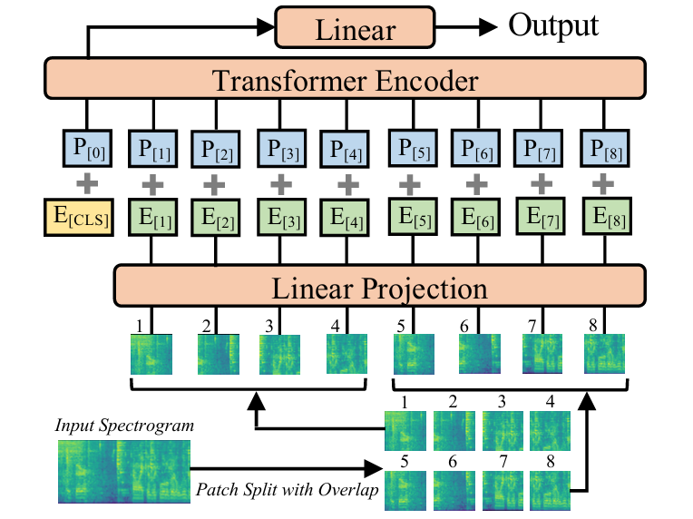
Figure 4 illustrates the proposed Audio Spectrogram Trans former (AST) architecture. First, the input audio waveform of t seconds is converted into a sequence of 128-dimensional log Mel filterbank (fbank) features computed with a 25ms Hamming window every 10ms. This results in a 128×100t spectrogram as input to the AST. We then split the spectrogram into a sequence of N 16×16 patches with an overlap of 6 in both time and frequency dimension, where N = 12 (100t − 16)/10 is the number of patches and the effective input sequence length for the Transformer. We flatten each 16×16 patch to a 1D patch embedding of size 768 using a linear projection layer. We refer to this linear projection layer as the patch embedding layer. Since the Transformer architecture does not capture the input order information and the patch sequence is also not in temporal order, we add a trainable positional embedding (also of size 768) to each patch embedding to allow the model to capture the spatial structure of the 2D audio spectrogram. Similar to [22], we append a [CLS] token at the beginning of the sequence. The resulting sequence is then input to the Transformer. A Transformer consists of several encoder and decoder layers. Since AST is designed for classification tasks, we only use the encoder of the Transformer. Intentionally, we use the original Transformer encoder [18] architecture without modification. The advantages of this simple setup are 1) the standard Transformer architecture is easy to implement and re produce as it is off-the-shelf in TensorFlow and PyTorch, and 2) we intend to apply transfer learning for AST, and a standard architecture makes transfer learning easier. Specifically, the Transformer encoder we use has an embedding dimension of 768, 12 layers, and 12 heads, which are the same as those in [12, 11]. The Transformer encoder’s output of the [CLS] token serves as the audio spectrogram representation. A linear layer with sigmoid activation maps the audio spectrogram representation to labels for classification.
Figure 4: Audio Spectrogram Transformer Architecture

